# Sample

## struct

### struct dwc_usb3_device *usb3_dev

typedef **struct dwc_usb3_device** {

**struct dwc_usb3_pcd pcd**;

uint32_t snpsid;

**dwc_usb3_core_params_t *core_params**;

**dwc_usb3_core_global_regs_t *core_global_regs**; // reg : 0xb0400000 + 0xC100

uint32_t **\*event_ptr**[1]; //usb3_dev->event_buf[0]

uint32_t **\*event_buf**[1]; //(0x00000000 + 0x90000)

dwc_dma_t **event_buf_dma**[1]; //usb3_dev->event_buf[0]

uint16_t total_fifo_size;

uint16_t rx_fifo_size;

uint32_t hwparams0; //reg_read(core_global_regs->ghwparams0)

uint32_t hwparams1; //reg_read(core_global_regs->ghwparams1)

uint32_t hwparams2; //reg_read(core_global_regs->ghwparams2)

uint32_t hwparams3; //reg_read(core_global_regs->ghwparams3)

uint32_t hwparams4; //reg_read(core_global_regs->ghwparams4)

uint32_t hwparams5; //reg_read(core_global_regs->ghwparams5)

uint32_t hwparams6; //reg_read(core_global_regs->ghwparams6)

uint32_t hwparams7; //reg_read(core_global_regs->ghwparams7)

uint32_t dcfg; //reg_read(dev_global_regs->dcfg)

unsigned int cmn_initialized : 1;

unsigned int pcd_initialized : 1;

unsigned int common_irq_installed : 1;

unsigned int sysfs_initialized : 1;

unsigned int phy_init_done : 1;

} dwc_usb3_device_t

### struct dwc_usb3_core_params

typedef **struct dwc_usb3_core_params** {

int burst; //0

int new; //0

int phy; //0

int wakeup; //0

int pwrctl; //0

} dwc_usb3_core_params_t;

### struct dwc_usb3_pcd pcd

typedef **struct dwc_usb3_pcd** {

**struct dwc_usb3_device *usb3_dev**;

int link_state; //0

ep0state_e ep0state; //EP0_UNCONNECTED

unsigned int ep0_status_pending : 1;

unsigned int request_config : 1;

unsigned int remote_wakeup_enable : 1;

unsigned int wkup_rdy : 1; //0

unsigned int eps_enabled : 1;

unsigned int pad : 3;

unsigned int devnum : 4;

unsigned int request_pending;

**dwc_usb3_pcd_ep_t *ep0**;

**dwc_usb3_pcd_ep_t *out_ep[DWC_MAX_EPS - 1]**;

**dwc_usb3_pcd_ep_t *in_ep[DWC_MAX_EPS - 1]**;

int test_mode;

**dwc_usb3_dev_global_regs_t *dev_global_regs**; // reg : 0xb0400000 + 0xC700

**dwc_usb3_dev_ep_regs_t *out_ep_regs**; // reg : 0xb0400000 + 0xC800

**dwc_usb3_dev_ep_regs_t *in_ep_regs**; // reg : 0xb0400000 + 0xC810

uint8_t speed; //0

uint8_t **num_out_eps**; // GHWPARAMS3 & 0x0003f000 - num_in_eps = 4

uint8_t **num_in_eps**; // GHWPARAMS3 & 0x007c0000 – 1 = 4

uint16_t tx_fifo_size[DWC_MAX_TX_FIFOS];

uint16_t rx_thr_en;

uint16_t iso_tx_thr_en;

uint16_t non_iso_tx_thr_en;

uint16_t rx_thr_length;

uint16_t tx_thr_length;

union {

usb_device_request_t req;

uint32_t d32[2];

} *setup_pkt; // (0x00000000 + 0xa0000)

dwc_dma_t setup_pkt_dma; // pcd->setup_pkt

uint8_t *status_buf; // (0x00000000 + 0xb0000)

dwc_dma_t status_buf_dma; // pcd->status_buf

dwc_dma_t dma_setup_desc_addr; // pcd->setup_desc_addr

dwc_usb3_dma_desc_t *setup_desc_addr; // (0x00000000 + 0xc0000)

dwc_dma_t dma_out_desc_addr; // pcd->out_desc_addr

dwc_usb3_dma_desc_t *out_desc_addr; // (0x00000000 + 0xd0000)

dwc_dma_t dma_in_desc_addr; // pcd->in_desc_addr

dwc_usb3_dma_desc_t *in_desc_addr; // (0x00000000 + 0xd0000)

dwc_usb3_pcd_request_t *ep0_req;

} dwc_usb3_pcd_t;

### struct dwc_usb3_pcd_ep

typedef **struct dwc_usb3_pcd_ep** {

**dwc_ep_t dwc_ep**;

struct { void *dummy; } usb_ep;

} dwc_usb3_pcd_ep_t;

### struct dwc_ep

typedef **struct dwc_ep** {

**struct dwc_usb3_pcd *pcd**;

const **usb_endpoint_descriptor_t *desc**; //ep[0]:=NULL; in_ep[1]= &_in1_desc_; out_ep[1]=&_out1_desc_

unsigned int stopped : 1; //1

unsigned int disabling : 1;

unsigned int queue_sof : 1; //0

unsigned int send_zlp : 1; //0

unsigned int stall_clear_flag : 1;

unsigned int three_stage : 1;

unsigned int isoc_started : 1;

unsigned int **is_in** : 1; // ep[0]:=0; in_ep[1-4]= 1; out_ep[1-4]= 0

unsigned int active : 1; //0

unsigned int data_pid_start : 1;

unsigned int even_odd_frame : 1;

uint8_t **num**; // ep[0]:=0; in_ep[1-4]= i; out_ep[1-4]= i

uint8_t **type;** //DWC_USB3_EP_TYPE_CONTROL

uint16_t **maxpacket**; // ep[0]:=64; in_ep[1-4]= 512; out_ep[1-4]= 512

uint8_t intvl;

uint8_t mult;

uint8_t maxburst;

uint8_t num_streams;

uint8_t tx_fifo_num; // ep[0]:=0; in_ep[1-4]= i; out_ep[1-4]= 0

uint8_t **tri_out**; //1: xfers out active

uint8_t **tri_in**; //1: xfers in active

uint8_t tri_out_initialize; //0

uint8_t tri_in_initialize; //0

uint32_t condition;

char *dma_desc;

dwc_dma_t dma_desc_dma;

int dma_desc_size;

int num_desc;

int desc_avail;

int desc_idx;

}

### struct usb_endpoint_descriptor_t;

typedef struct {

uByte bLength; //7

uByte **bDescriptorType**; //USB_DT_ENDPOINT

uByte **bEndpointAddress**; //in: 0x81, out:0x01

uByte **bmAttributes**; //0x02: bulk

uWord **wMaxPacketSize**; //512

uByte bInterval;

} usb_endpoint_descriptor_t;

### struct dwc_usb3_pcd_request

typedef struct dwc_usb3_pcd_request {

dwc_req_t dwc_req;

} dwc_usb3_pcd_request_t;

### struct dwc_req

typedef struct dwc_req {

void *buf; /**< data buffer */

dwc_dma_t dma; /**< DMA address of data buffer */

dwc_usb3_dma_desc_t *trb; /**< TRB for this request */

dwc_dma_t trb_dma; /**< DMA address of TRB */

uint32_t length; /**< length of data buffer */

uint32_t actual; /**< actual amount of data transfered */

uint32_t stream; /**< stream # of this request */

int flags;

} dwc_req_t;

### struct _ATAPI sAtapi

typedef struct _ATAPI{

UNION_CBW uCbw;

UNION_CSW uCsw;

INQUIRY_DATA sInquiryData;

READ_FORMAT_CAPACITIES_DATA sReadFormatCapacitiesData;

READ_CAPACITIES_DATA sReadCapacitiesData;

MODE_SENSE_5A_DATA sModeSense5AData;

MODE_SENSE_1A_DATA sModeSense1AData;

REQUEST_SENSE_DATA sRequestSenseData;

UINT dAtaId[64]; //dAtaId[30] = 0x00008000 = 32k*512B=16M

UCHAR bMscStage; //means the next stage

}ATAPI,*PATAPI; //__attribute__ ((unpacked,aligned()))

### struct _INQUIRY_DATA

typedef struct _INQUIRY_DATA{

UCHAR PeripheralDeviceType; //0x00

UCHAR RMB; //0x80

UCHAR ISO_ECMA_ANSI_version; //0x00

UCHAR ResponseDataFormat; //0x01

UCHAR AdditionalLength; //0x31

UCHAR Reserved0; //0x00

UCHAR Reserved1; //0x00

UCHAR Reserved2; //0x00

UCHAR VendorInformation[8]; //”ACTIONS”

UCHAR ProductIdentification[16]; //”USB2.0 OTG DISK”

UCHAR ProductVersionLevel[4]; //”1.00”

} INQUIRY_DATA, * PINQUIRY_DATA;

### struct _READ_FORMAT_CAPACITIES_DATA

typedef struct _READ_FORMAT_CAPACITIES_DATA{

UINT dCapacityListHeader; //0x08000000

UCHAR bCurrentMaxCapacityNumOfBlocks[4]; //sAtapi.dAtaId[30]

UCHAR bCurrentMaxCapacityDescrptCode; //1

UCHAR bCurrentMaxCapacityBlockLength[3]; //0x200 = 512B

UCHAR bFormattableCapacityNumOfBlocks[4]; //sAtapi.dAtaId[30]

UINT dFormattableCapacityBlockLength; //0x00020000 = 128k*512B=64M

} READ_FORMAT_CAPACITIES_DATA, * PREAD_FORMAT_CAPACITIES_DATA;

### struct _READ_CAPACITIES_DATA

typedef struct _READ_CAPACITIES_DATA{

UCHAR bLastLogicBlockAddress[4]; //sAtapi.dAtaId[30] - 1

UINT dBlockLength; //0x00020000 = 128k*512B=64M

} READ_CAPACITIES_DATA, * PREAD_CAPACITIES_DATA;

### struct _MODE_SENSE_5A_DATA

typedef struct _MODE_SENSE_5A_DATA{

UCHAR bModeParamHeader[8]; //0

MODE_SENSE_PAGE sModeSensePage;

} MODE_SENSE_5A_DATA, * PMODE_SENSE_5A_DATA;

### struct _MODE_SENSE_1A_DATA

typedef struct _MODE_SENSE_1A_DATA{

UCHAR bModeParamHeader[4]; //0

MODE_SENSE_PAGE sModeSensePage;

} MODE_SENSE_1A_DATA, * PMODE_SENSE_1A_DATA;

### struct _MODE_SENSE_PAGE

typedef struct _MODE_SENSE_PAGE{

UCHAR bTimerProtectPage[8]; //0x03000600 | TimerProtectPage(0x1c)

UCHAR bRwErrRecoveryPage[12]; //0x00000A00 | RwErrRecoveryPage(0x01)

UCHAR bCacheingPage[12]; //0x00010A00 | CacheingPage(0x08)

UCHAR bRemovableBlockPage[12]; //0x00000A00 | RemovableBlockPage(0x1b)

} MODE_SENSE_PAGE, * PMODE_SENSE_PAGE;

### struct _REQUEST_SENSE_DATA

### dwc_usb3_cil_callbacks_t pcd_callbacks

typedef struct _REQUEST_SENSE_DATA{

UCHAR bErrCode; //0x70

UCHAR bReserved0; //0x0

UCHAR bSenseKey0; //0x0

UCHAR bInformation0; //0x0

UCHAR bInformation1; //0x0

UCHAR bInformation2; //0x0

UCHAR bInformation3; //0x0

UCHAR bAdditionalSenseLength; //0x0

UCHAR bReserved1; //0x0

UCHAR bReserved2; //0x0

UCHAR bReserved3; //0x0

UCHAR bReserved4; //0x0

UCHAR bAdditionalSenseCode; //0x0

UCHAR bAdditionalSenseCodeQualifier; //0x0

UCHAR bFieldReplacebleUnitCode; //0x0

UCHAR bSKSV; //0x0

UCHAR bSenseKeyS0; //0x0

UCHAR bSenseKeyS1; //0x0

} REQUEST_SENSE_DATA, * PREQUEST_SENSE_DATA;

static dwc_usb3_cil_callbacks_t pcd_callbacks = {

.start = pcd_start_cb,

.stop = pcd_stop_cb,

.suspend = pcd_suspend_cb,

.resume_wakeup = pcd_resume_cb,

.p = 0, // **struct dwc_usb3_pcd**

};

## Function

### dwc_usb3_mode() //get usb mode

static inline uint32_t dwc_usb3_mode(dwc_usb3_device_t *usb3_dev)

{

return dwc_read_reg32(&usb3_dev->core_global_regs->**gsts**) & **0x1**; // 0 - Device Mode, 1 - Host Mode

}

### init_devspd() //clean address

//clean the address

static void init_devspd(dwc_usb3_device_t *usb3_dev)

{

dwc_modify_reg32(&usb3_dev->pcd.dev_global_regs->**dcfg**,

DWC_DCFG_DEVADDR_BITS, 0 << DWC_DCFG_DEVADDR_SHIFT);

}

DWC_DCFG_DEVADDR_BITS = 0x0003f8, //Device Address

DWC_DCFG_DEVADDR_SHIFT = 3,

### calc_num_in_eps() //get in_ep_nums

GHWPARAMS3 = 0x0514a085

In_ep_nums = 0x0514a085 & 0x007c0000 -1 = 00101b -1 = 0x5 – 1 = 0x4;

static uint32_t calc_num_in_eps(dwc_usb3_device_t *usb3_dev)

{

uint32_t num_in_eps = (usb3_dev->hwparams3 >> DWC_HWPARAMS3_NUM_IN_EPS_SHIFT) &

(DWC_HWPARAMS3_NUM_IN_EPS_BITS >> DWC_HWPARAMS3_NUM_IN_EPS_SHIFT);

return num_in_eps - 1;

}

DWC_HWPARAMS3_NUM_IN_EPS_BITS = 0x007c0000,

### calc_num_out_eps() //get out_ep_nums

GHWPARAMS3 = 0x0514a085

out_ep_nums = 0x0514a085 & 0x0003f000 – in_ep_nums -1 = 001010b – 0x5 - 1 = 0xa – 0x5 - 1 = 0x4;

static uint32_t calc_num_out_eps(dwc_usb3_device_t *usb3_dev)

{

uint32_t num_eps = (usb3_dev->hwparams3 >> DWC_HWPARAMS3_NUM_EPS_SHIFT) &

(DWC_HWPARAMS3_NUM_EPS_BITS >> DWC_HWPARAMS3_NUM_EPS_SHIFT);

uint32_t num_in_eps = (usb3_dev->hwparams3 >> DWC_HWPARAMS3_NUM_IN_EPS_SHIFT) &

(DWC_HWPARAMS3_NUM_IN_EPS_BITS >> DWC_HWPARAMS3_NUM_IN_EPS_SHIFT);

return num_eps - num_in_eps - 1;

}

DWC_HWPARAMS3_NUM_EPS_BITS = 0x0003f000,

### dis_eventbuf_intr () //disable Event Buffer interrupt

static void dis_eventbuf_intr(dwc_usb3_device_t *dev, int bufno) // bufno = 0

{

dwc_modify_reg32(&dev->core_global_regs->geventbuf[bufno].**geventsiz**,

DWC_EVENTSIZ_INT_MSK_BIT, DWC_EVENTSIZ_INT_MSK_BIT);

}

DWC_EVENTSIZ_INT_MSK_BIT = 0x80000000, // Event Interrupt Mask

DWC_EVENTSIZ_INT_MSK_SHIFT = 31

### ena_eventbuf_intr() //enables Event Buffer interrupt

static void ena_eventbuf_intr(dwc_usb3_device_t *dev, int bufno)

{

dwc_modify_reg32(&dev->core_global_regs->geventbuf[bufno].**geventsiz**,

DWC_EVENTSIZ_INT_MSK_BIT, 0);

}

DWC_EVENTSIZ_INT_MSK_BIT = 0x80000000, // Event Interrupt Mask

### dis_flush_eventbuf_intr() //disable and flush event buffer interrupt

static void dis_flush_eventbuf_intr(dwc_usb3_device_t *dev, int bufno) // bufno = 0

{

dis_eventbuf_intr(dev, bufno); //disable Event Buffer interrupt

// flushes any pending events from the buffer

cnt = dwc_read_reg32(&dev->core_global_regs->geventbuf[bufno].**geventcnt**);

dwc_write_reg32(&dev->core_global_regs->geventbuf[bufno].**geventcnt**, cnt);

}

### dwc_usb3_enable_common_interrupts() //enable common interrupt

void dwc_usb3_enable_common_interrupts(dwc_usb3_device_t *usb3_dev)

{

dis_flush_eventbuf_intr(usb3_dev, 0);

ena_eventbuf_intr(usb3_dev, 0);

}

### dwc_usb3_enable_device_interrupts() //enable device interrupt

void dwc_usb3_enable_device_interrupts(dwc_usb3_device_t *usb3_dev)

{

dwc_usb3_enable_common_interrupts(usb3_dev);

dwc_write_reg32(&usb3_dev->pcd.dev_global_regs->**devten**,

DWC_DEVTEN_DISCONN_BIT |

DWC_DEVTEN_USBRESET_BIT |

DWC_DEVTEN_CONNDONE_BIT |

DWC_DEVTEN_ULST_CHNG_EN_BIT);

}

DWC_DEVTEN_DISCONN_BIT = 0x0001, // Disconnect Detected Event Enable

DWC_DEVTEN_USBRESET_BIT = 0x0002, // USB Reset Enable

DWC_DEVTEN_CONNDONE_BIT = 0x0004, // Connect Done Enable

DWC_DEVTEN_ULST_CHNG_EN_BIT = 0x0008, // USB/Link State Change Event Enable

### Set the Run/Stop bit

// Set the Run/Stop bit

dwc_modify_reg32(&pcd->dev_global_regs->dctl,

DWC_DCTL_RUN_STOP_BIT, DWC_DCTL_RUN_STOP_BIT);

DWC_DCTL_RUN_STOP_BIT = 0x80000000, // Run/Stop

DWC_DCTL_RUN_STOP_SHIFT = 31,

## Cmd

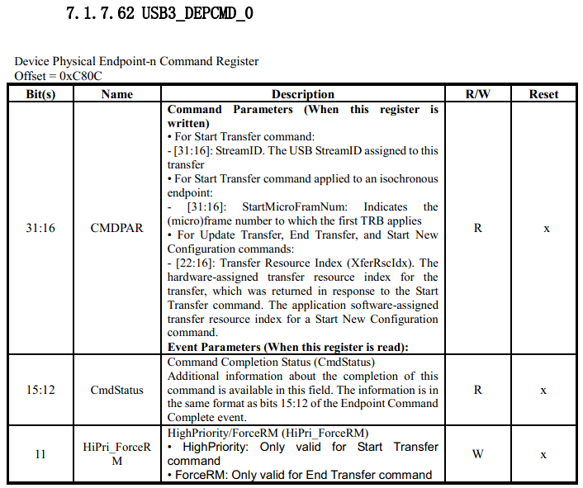

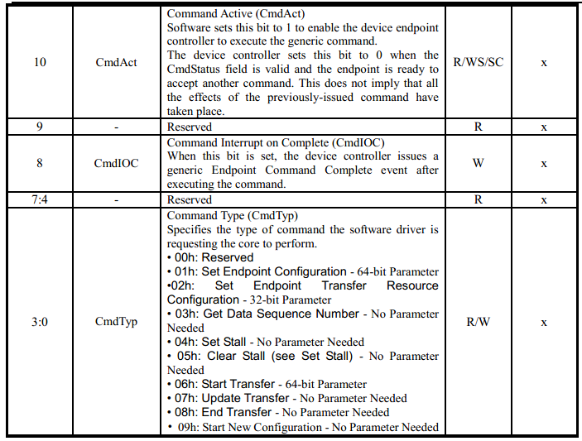

Ep0:

DEPCMDPAR2(0) = 0x00000000

DEPCMDPAR1(0) = 0x11042000 //Transfer Descriptor Address (Low)

DEPCMDPAR0(0) = 0x00000000 //Transfer Descriptor Address (High)

DEPCMD(0) = 0x0000000**6** // DWC_EPCMD_START_XFER

Ep_in:

DEPCMDPAR2(1) = 0x00000000

DEPCMDPAR1(1) = 0x11042000

DEPCMDPAR0(1) = 0x00000000

DEPCMD(1) = 0x000**1**000**6** // DWC_EPCMD_START_XFER | Stream_ID(1)

Ep_out:

DEPCMDPAR2(5) = 0x00000000

DEPCMDPAR1(5) = 0x11049010

DEPCMDPAR0(5) = 0x00000000

DEPCMD(5) = 0x000**2**200**6** // DWC_EPCMD_START_XFER | Stream_ID(2)

### Depcmd[3:0]: Cmd Type

DWC_EPCMD_SET_EP_CFG = 1, /** @< */

DWC_EPCMD_SET_XFER_CFG = 2, /** @< */

DWC_EPCMD_CLR_DATA_SEQ = 3, /** @< */

DWC_EPCMD_SET_STALL = 4, /** @< */

DWC_EPCMD_CLR_STALL = 5, /** @< */

DWC_EPCMD_START_XFER = 6, /** @< */

DWC_EPCMD_UPDATE_XFER = 7, /** @< */

DWC_EPCMD_END_XFER = 8, /** @< */

DWC_EPCMD_START_NEW_CFG = 9,

### dwc_usb3_dep_startnewcfg() // DWC_EPCMD_START_NEW_CFG(9)

XferRscIdx = 0: 即将发送SET_EP_CFG命令配置endpoints 0 and 1；

XferRscIdx = 2: 即将发送SET_EP_CFG命令配置endpoints > 1；

int dwc_usb3_dep_startnewcfg(dwc_usb3_pcd_t *pcd, uint32_t XferRscIdx)

{

/* Start the command */

dwc_write_reg32(&ep_reg->**depcmd**, (**XferRscIdx**<< 16) |**DWC_EPCMD_START_NEW_CFG** |**DWC_EPCMD_ACT_BIT**);

/* Wait for command completion */

if (!dwc_usb3_handshake(pcd->usb3_dev, &ep_reg->**depcmd**, **DWC_EPCMD_ACT_BIT**, **0**, 1000)) { }

return 0;

}

DWC_EPCMD_START_NEW_CFG = 9, // Command Type values: start new cfg

DWC_EPCMD_ACT_BIT = 0x400, // Command Active

### dwc_usb3_dep_cfg() // DWC_EPCMD_SET_EP_CFG(1)

不同的endpoint需要发送不同参数的START_NEW_CFG命令

Ep[0]:

depcfg0 = b[2:1] | b[13:3]

depcfg1 = b[8] |b[10]

Ep_out[n]:

depcfg0 = b[2:1] | b[13:3] |

depcfg1 = b[26] | b[16] | b[8] |b[9]

Ep_int[n]:

depcfg0 = b[2:1] | b[13:3] | b[21:17]

depcfg1 = b[26] | b[16] | b[8] |b[9] | b[25]

* DEPCMDPAR0:
  + b[0]: Reserved
  + b[2:1]: Endpoint Type values

DWC_USB3_EP_TYPE_CONTROL = 0, /** @< */

DWC_USB3_EP_TYPE_ISOC = 1, /** @< */

DWC_USB3_EP_TYPE_BULK = 2, /** @< */

DWC_USB3_EP_TYPE_INTR = 3,

* + b[13:3]: Max Packet Size
    - EP0:

#define DWC_MAX_EP0_SIZE_SS 512

#define DWC_MAX_EP0_SIZE_HS 64

* + - EP[n]

#define DWC_MAX_PACKET_SIZE_SS 1024

#define DWC_MAX_PACKET_SIZE_HS 512

#define DWC_MAX_PACKET_SIZE_FS 64

* + b[16:14]: Reserved
  + b[21:17]: FIFO Number
* DEPCMDPAR1
  + b[4-0]: Interrupt number
  + b[7:5]: Reserved
  + b[8]: DWC_EPCFG1_XFER_CMPL_BIT, // XferComplete : Stream Completed
  + b[9]: DWC_EPCFG1_XFER_IN_PROG_BIT, // XferInProgress : Stream In Progress
  + b[10]: DWC_EPCFG1_XFER_NRDY_BIT, // XferNotReady : Stream Not Ready
  + b[11]: DWC_EPCFG1_FIFOXRUN_BIT, // Rx FIFO Underrun / Tx FIFO Overrun
  + b[12]: DWC_EPCFG1_SETUP_PNDG_BIT, // Back-to-Back Setup Packets Received
  + b[13]: DWC_EPCFG1_EPCMD_CMPL_BIT, // Endpoint Command Complete
  + b[16]: DWC_EPCFG1_BINTERVAL_BITS, // Endpoint bInterval
  + b[24]: DWC_EPCFG1_STRM_CAP_BIT, // Endpoint Stream Capability
  + b[25]: DWC_EPCFG1_EP_DIR_BIT, // Endpoint Direction
  + b[26]: DWC_EPCFG1_EP_NUM_BITS, // Endpoint Number

int dwc_usb3_dep_cfg(dwc_usb3_pcd_t *pcd , dwc_usb3_dev_ep_regs_t *ep_reg, uint32_t depcfg0, uint32_t depcfg1)

{

dwc_write_reg32(&ep_reg->**depcmdpar1**, **depcfg1**); // depcfg1

dwc_write_reg32(&ep_reg->**depcmdpar0**, **depcfg0**); // depcfg0

/* Start the command */

dwc_write_reg32(&ep_reg->**depcmd**, **DWC_EPCMD_SET_EP_CFG** | **DWC_EPCMD_ACT_BIT**);

/* Wait for command completion */

if (!dwc_usb3_handshake(pcd->usb3_dev, &ep_reg->**depcmd**, **DWC_EPCMD_ACT_BIT**, **0**, 1000)){}

return 0;

}

DWC_EPCMD_SET_EP_CFG = 1, // Command Type values: set ep cfg

### dwc_usb3_dep_xfercfg() // DWC_EPCMD_SET_XFER_CFG(2)

int dwc_usb3_dep_xfercfg(dwc_usb3_pcd_t *pcd, , dwc_usb3_dev_ep_regs_t *ep_reg, uint32_t depstrmcfg)

{

//**depstrmcfg** = 1; //**One stream**

dwc_write_reg32(&ep_reg->**depcmdpar0**, **depstrmcfg**);

/* Start the command */

dwc_write_reg32(&ep_reg->**depcmd**,**DWC_EPCMD_SET_XFER_CFG** | **DWC_EPCMD_ACT_BIT**);

/* Wait for command completion */

if (!dwc_usb3_handshake(pcd->usb3_dev, &ep_reg->**depcmd**, **DWC_EPCMD_ACT_BIT**, **0,** 1000)){}

return 0;

}

DWC_EPCMD_SET_XFER_CFG = 2 // Command Type values: set xfer cfg

### dwc_usb3_dep_sstall() // DWC_EPCMD_SET_STALL(4)

设置DWC_EPCMD_IOC_BIT后，当执行CLR_STALL后会产生中断

int dwc_usb3_dep_sstall(dwc_usb3_pcd_t *pcd, dwc_usb3_dev_ep_regs_t *ep_reg)

{

dwc_write_reg32(&ep_reg->**depcmd**,**DWC_EPCMD_SET_STALL** | DWC_EPCMD_ACT_BIT | **DWC_EPCMD_IOC_BIT**);

/* Wait for command completion */

if (!dwc_usb3_handshake(pcd->usb3_dev, &ep_reg->depcmd, DWC_EPCMD_ACT_BIT, 0, 1000)){}

return 0;

}

DWC_EPCMD_SET_STALL = 4

DWC_EPCMD_IOC_BIT = 0x100, // **Command Interrupt on Complete**

### dwc_usb3_dep_cstall() // DWC_EPCMD_CLR_STALL(5)

int dwc_usb3_dep_cstall(dwc_usb3_pcd_t *pcd, dwc_usb3_dev_ep_regs_t *ep_reg)

{

dwc_write_reg32(&ep_reg->**depcmd**,**DWC_EPCMD_CLR_STALL** | DWC_EPCMD_ACT_BIT);

/* Wait for command completion */

if (!dwc_usb3_handshake(pcd->usb3_dev, &ep_reg->depcmd, DWC_EPCMD_ACT_BIT, 0, 1000)){}

return 0;

}

DWC_EPCMD_CLR_STALL = 5,

### dwc_usb3_dep_startxfer() // DWC_EPCMD_START_XFER(6)

int dwc_usb3_dep_startxfer(dwc_usb3_pcd_t *pcd, dwc_usb3_dev_ep_regs_t *ep_reg, dwc_dma_t dma_addr, uint32_t stream_or_uf)

{

dwc_write_reg32(&ep_reg->**depcmdpar1**,**dma_addr** & 0xffffffffU);

dwc_write_reg32(&ep_reg->**depcmdpar0**, 0);

/* Start the command */

dwc_write_reg32(&ep_reg->**depcmd**, (**stream_or_uf** << (16)) | **DWC_EPCMD_START_XFER** | DWC_EPCMD_ACT_BIT);

/* Wait for command completion */

if (!dwc_usb3_handshake(pcd->usb3_dev, &ep_reg->depcmd, DWC_EPCMD_ACT_BIT, 0, 1000)){}

depcmd = dwc_read_reg32(&ep_reg->**depcmd**);

return (depcmd >> (16)) & (**DWC_EPCMD_XFER_RSRC_IDX_BITS** >> (16));

}

DWC_EPCMD_START_XFER = 6,

DWC_EPCMD_XFER_RSRC_IDX_BITS = 0x007f0000, // Transfer Resource Index (output)

### dwc_usb3_dep_updatexfer() // DWC_EPCMD_UPDATE_XFER(7)

int dwc_usb3_dep_updatexfer(dwc_usb3_pcd_t *pcd, dwc_usb3_dev_ep_regs_t *ep_reg, uint32_t tri)

{

/* Start the command */

dwc_write_reg32(&ep_reg->**depcmd**,(**tri** << (16)) | **DWC_EPCMD_UPDATE_XFER** | DWC_EPCMD_ACT_BIT);

/* Wait for command completion */

if (!dwc_usb3_handshake(pcd->usb3_dev, &ep_reg->depcmd, DWC_EPCMD_ACT_BIT, 0, 10000)){}

return 0;

}

DWC_EPCMD_UPDATE_XFER = 7,

### dwc_usb3_dep_endxfer() // DWC_EPCMD_END_XFER(8)

int dwc_usb3_dep_endxfer(dwc_usb3_pcd_t *pcd, dwc_usb3_dev_ep_regs_t *ep_reg, uint32_t tri, void *condition)

{

/* Start the command. */

dwc_write_reg32(&ep_reg->**depcmd**,

(**tri** << (16)) | **DWC_EPCMD_END_XFER** | DWC_EPCMD_ACT_BIT | **DWC_EPCMD_HP_FRM_BIT**);

/* Wait for command completion */

if (!dwc_usb3_handshake(pcd->usb3_dev, &ep_reg->depcmd, DWC_EPCMD_ACT_BIT, 0, 10000)){}

return 0;

}

DWC_EPCMD_END_XFER = 8,

DWC_EPCMD_HP_FRM_BIT = 0x800, // **High Priority / Force RM Bit**

### dwc_usb3_ep0_activate() //ep0 active

void dwc_usb3_ep0_activate(dwc_usb3_pcd_t *pcd)

{

//Issue "DEPCFG" command to EP0-OUT

ep_reg = &pcd->**out_ep_regs[0]**;

doepcfg0 = DWC_USB3_EP_TYPE_**CONTROL**<< (1) | DWC_MAX**_EP0_SIZE_HS**<< (3)**;**

doepcfg1 = DWC_EPCFG1_**XFER_CMPL_BIT** | DWC_EPCFG1_**XFER_NRDY_BIT;**

dwc_usb3_dep_startnewcfg(pcd, ep_reg, 0); // DWC_EPCMD_START_NEW_CFG

dwc_usb3_dep_cfg(pcd, ep_reg, doepcfg0, doepcfg1); // DWC_EPCMD_SET_EP_CFG

dwc_usb3_dep_xfercfg(pcd, ep_reg, 1); // DWC_EPCMD_SET_XFER_CFG

//Issue "DEPCFG" command to EP0-IT

ep_reg = &pcd->**in_ep_regs[0]**;

diepcfg0 = DWC_USB3_EP_TYPE_**CONTROL**<< (1) | DWC_MAX_**EP0_SIZE_HS** << (3);

diepcfg1 = DWC_EPCFG1_**XFER_CMPL_BIT** | DWC_EPCFG1_**XFER_NRDY_BI**T | DWC_EPCFG1_**EP_DIR_BIT**;

dwc_usb3_dep_cfg(pcd, ep_reg, diepcfg0, diepcfg1); // DWC_EPCMD_SET_EP_CFG

dwc_usb3_dep_xfercfg(pcd, ep_reg, 1); // DWC_EPCMD_SET_XFER_CFG

}

DWC_USB3_EP_TYPE_CONTROL = 0,

#define DWC_MAX_EP0_SIZE_HS 64

DWC_EPCFG1_XFER_CMPL_BIT = 0x00000100, // Stream Completed

DWC_EPCFG1_XFER_NRDY_BIT = 0x00000400, // Stream Not Ready

DWC_EPCFG1_EP_DIR_BIT = 0x02000000, // Endpoint Direction

### dwc_usb3_ep_activate()

void dwc_usb3_ep_activate(dwc_usb3_pcd_t *pcd, dwc_usb3_pcd_ep_t *ep)

{

if (ep->**dwc_ep.is_in**) {

ep_reg = &pcd->**in_ep_regs**[ep->dwc_ep.num];

**ep_index_num** = **ep->dwc_ep.num** * 2 + 1;

}

else {

ep_reg = &pcd->**out_ep_regs**[ep->dwc_ep.num];

**ep_index_num** = **ep->dwc_ep.num** * 2;

}

depcfg0 = ep->**dwc_ep.type** << (1) | ep->**dwc_ep.maxpacket** << (3);

if (pcd->usb3_dev->core_params->burst)

depcfg0 |= 0 << DWC_EPCFG0_BRSTSIZ_SHIFT;

depcfg1 = ep->**dwc_ep.num** << (26) | ep->**dwc_ep.intvl** << (16)

| DWC_EPCFG1_**XFER_CMPL_**BIT | DWC_EPCFG1_**XFER_IN_PROG**_BIT;

if (ep->**dwc_ep.is_in**) {

depcfg0 |= ep->**dwc_ep.tx_fifo_num** << (17);

depcfg1 |= DWC_EPCFG1_E**P_DIR_BIT;**

}

dwc_usb3_dep_cfg(pcd, ep_reg, depcfg0, depcfg1);

dwc_usb3_dep_xfercfg(pcd, ep_reg, **1**);

/* Enable EP in DALEPENA reg */

dalepena |= 1 << **ep_index_num**;

dwc_write_reg32(&pcd->dev_global_regs->**dalepena**, dalepena);

ep->dwc_ep.stall_clear_flag = 0;

}

## Event

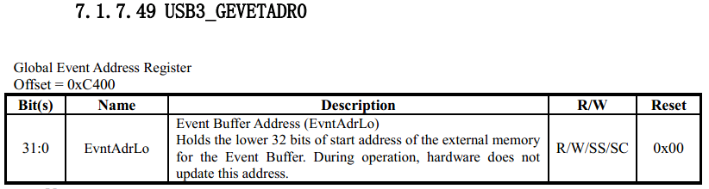

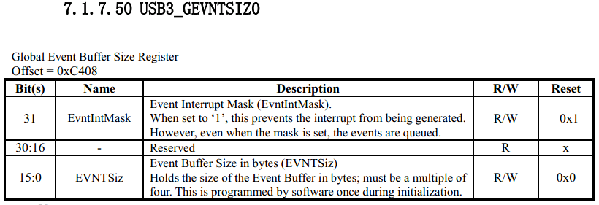

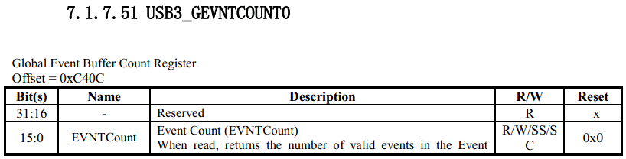



GEVNTADRLO(0) = 0x11040000

GEVNTADRHI(0) = 0x00000000

GEVNTSIZ(0) = 0x00000100

GEVNTCOUNT(0) = 0x00000000

GEVNTADRHI(0) | GEVNTADRLO(0)表示Events存放的地址；

GEVNTSIZ(0) = 0x00000100 * 4 = 1024B表示该地址长度；每个event占用空间为4B；

GEVNTCOUNT(0)表示当前dma中存放的待处理event集合；

* Event:

Event:b[0] :1= non-endpoint event, 0= endpoint event

* + non-endpoint event:

Event:b[1] :1= device event, 0= core event

* + - device event

Event:b[11-8] :

DWC_DEVT_DISCONN = 0,

DWC_DEVT_USBRESET = 1,

DWC_DEVT_CONNDONE = 2,

DWC_DEVT_ULST_CHNG = 3,

DWC_DEVT_WKUP = 4,

DWC_DEVT_EOPF = 6,

DWC_DEVT_SOF = 7,

DWC_DEVT_ERRATICERR = 9,

DWC_DEVT_CMD_CMPL = 10,

DWC_DEVT_OVERFLOW = 11,

DWC_DEVT_VNDR_DEV_TST_RCVD = 12,

DWC_DEVT_INACT_TIMEOUT_RCVD = 13,

* + endpoint event

Event:b[5-1] : Out EPs are even, In EPs are odd

Event:b[9-6] :

DWC_DEPEVT_XFER_CMPL = 1,

DWC_DEPEVT_XFER_IN_PROG = 2,

DWC_DEPEVT_XFER_NRDY = 3,

DWC_DEPEVT_FIFOXRUN = 4,

DWC_DEPEVT_STRM_EVT = 6,

DWC_DEPEVT_EPCMD_CMPL = 7,

### init_eventbuf()

static void init_eventbuf(dwc_usb3_device_t *dev)

{

Bufno = 0;

// Up to 32 Event Buffers are supported by the hardware, but we only use 1

usb3_dev->event_buf[0] = allocate_eventbuf(usb3_dev,DWC_EVENT_BUF_SIZE);

usb3_dev->event_buf_dma[0] = (dwc_dma_t)(usb3_dev->event_buf[0]);

usb3_dev->event_ptr[0] = usb3_dev->event_buf[0];

dma_addr = usb3_dev->**event_buf_dma**[0];

size = DWC_EVENT_BUF_SIZE = 1024*8; //dwords

dwc_write_reg32(&dev->core_global_regs->geventbuf[bufno].**geventadr_lo**, **dma_addr** & 0xffffffffU);

dwc_write_reg32(&dev->core_global_regs->geventbuf[bufno].**geventadr_hi**, 0);

dwc_write_reg32(&dev->core_global_regs->geventbuf[bufno].**geventsiz**, **size** << 2);

dwc_read_reg32(&dev->core_global_regs->geventbuf[bufno].**geventsiz**);

dwc_write_reg32(&dev->core_global_regs->geventbuf[bufno].**geventcnt**, 0);

}

#define DWC_EVENT_BUF_SIZE 1024*8 // size in dwords

### get_eventbuf_count()

//如果**geventcnt** =0xffff 或者**geventcnt** >= DWC_EVENT_BUF_SIZE * 4 🡪 Bad event count

static int get_eventbuf_count(dwc_usb3_device_t *dev)

{

bufno = 0;

cnt = dwc_read_reg32(&dev->core_global_regs->geventbuf[bufno].**geventcnt**);

return cnt & DWC_EVENTCNT_CNT_BITS;

}

DWC_EVENTCNT_CNT_BITS = 0x0000ffff,

### get_eventbuf_event()

static uint32_t get_eventbuf_event(dwc_usb3_device_t *dev, int bufno, int size)

{

bufno = 0;

size = DWC_EVENT_BUF_SIZE; // 1024*8 dwords

uint32_t **event = *dev->event_ptr[bufno]++**;

if (dev->event_ptr[bufno] >= dev->event_buf[bufno] + size) dev->event_ptr[bufno] = dev->event_buf[bufno];

return event;

}

### update_eventbuf_count()

//执行get_eventbuf_event()后，需要执行update_eventbuf_count()来更新event的值

static void update_eventbuf_count(dwc_usb3_device_t *dev)

{

Bufno = 0;

Cnt = 4; //dword

dwc_write_reg32(&dev->core_global_regs->geventbuf[bufno].geventcnt, cnt);

}

### device event

#### DWC_DEVT_DISCONN

static uint32_t calc_num_in_eps(dwc_usb3_device_t *usb3_dev)

{

uint32_t num_in_eps = (usb3_dev->hwparams3 >> DWC_HWPARAMS3_NUM_IN_EPS_SHIFT) &

(DWC_HWPARAMS3_NUM_IN_EPS_BITS >> DWC_HWPARAMS3_NUM_IN_EPS_SHIFT);

return num_in_eps - 1;

}

# End